Kurt Medley  
Stats Take-home Midterm  
May 2013

Question 3

1.

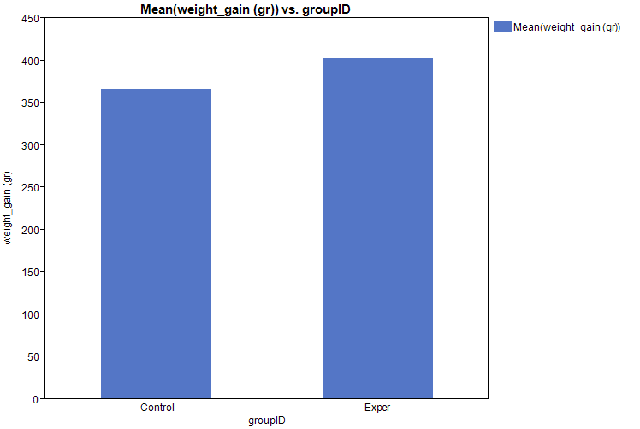

The data are within approximate range and a t-test is suitable given the sample size. There are no significantly unreachable subjects outside of the range of 275 grams and 475 grams.

1. H0: Subjects fed high-lysine corn do not gain weight faster than chicks fed normal corn.

Ha: There is a higher weight gain associated with chicks that eat high-lysine corn than there is with chicks that eat regular corn.

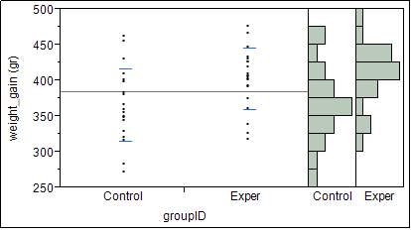

Given the plot we can assert that the experimental subjects (chicks fed corn with high-lysine) have higher weight gains than the ones fed regular corn. We can see that the average for those in the experimental group have more chicks above the 375 gram marker than the control group.

1. (optional) give a 95% confidence interval for the mean extra weight gain in chicks fed high-lysine corn.

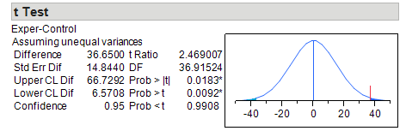

Question 4

1. Make a table of means and standard deviations for the four colors and present the data graphically.

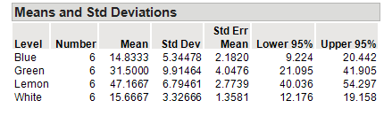

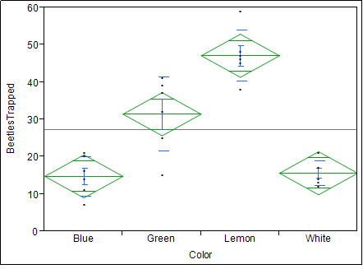

1. State the null and alternative hypotheses for an ANOVA on these data, and explain in words what the ANOVA will test in this setting.

H0: The colors of the board have no effect on the number of beetles trapped in the field of oats.

Ha: Specific board colors have an effect on the number of beetles trapped in the field of oats.

The one-way ANOVA will give a summary of fit test in which it will calculate the coefficient of determination. It will provide a measure of how well an observed outcome will be replicated by the model. Analysis of variance gives a statistical test of the means of several groups and determines whether or not they are equal. It generalizes the t-test of more than one group (aka Blue, Green, Lemon, White).

1. Run the ANOVA (in JMP or resampling) and report your results.

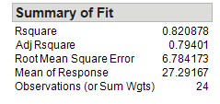 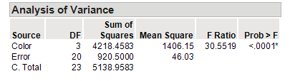

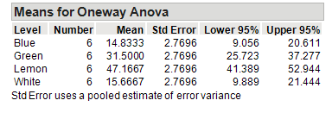

We notice that there isn’t a significant difference between beetles trapped by colors Blue and White. They represent the most ineffective colors for trapping beetles. Green boards attract more beetles than Blue and White, and Lemon boards represent the best colors for attracting beetles. Evaluating the means shows us the difference in beetles trapped between colors. Our Rsquared (or coefficient of determination) value shows an (approx.) 80% accuracy of observed outcomes presented by the model.